C845 Task 2
Incident and Network Security Artifacts

The provided artifacts are excerpts and summaries adapted from realistic incident and network data. The artifacts are representative but not exhaustive. You are required to analyze and infer from the available information.

1. Incident Summary and Timeline

Incident: On June 24, 2025, an HR employee opened a malicious PDF attachment from a phishing email, resulting in the installation of a GhostX remote access Trojan (RAT). The IDS detected unusual outbound traffic, triggering containment procedures.

Time Stamp | Event Description
06/24/2025 – 09:12: | HR user receives phishing email with "Updated Benefits Plan" PDF
06/24/2025 – 09:14: | Attachment opened; malware installed silently
06/24/2025 – 09:52: | Unusual outbound traffic detected by IDS
06/24/2025 – 10:07: | Affected machine isolated from network
06/24/2025 – 11:25: | Malware identified as GhostX RAT
06/24/2025 – 13:45: | End point restored from backup; AV scans initiated on HR subnet
06/25/2025 – 08:30: | Antivirus definitions updated across all end points
06/25/2025 – 10:00: | Internal review initiated to evaluate incident handling

2. Current Incident Response Procedure (Summary)
- Detection: All alerts monitored through a centralized IDS
- Notification: On-call IT staff alerted via SMS and email
- Containment: Affected machine isolated by disabling the network port
- Eradication: AV and antimalware tools deployed to remove known threats
- Recovery: Systems restored from the most recent backups
- Post-Incident Review: Debrief scheduled only if the threat affects multiple departments

3. Network Architecture Diagram (Simplified)

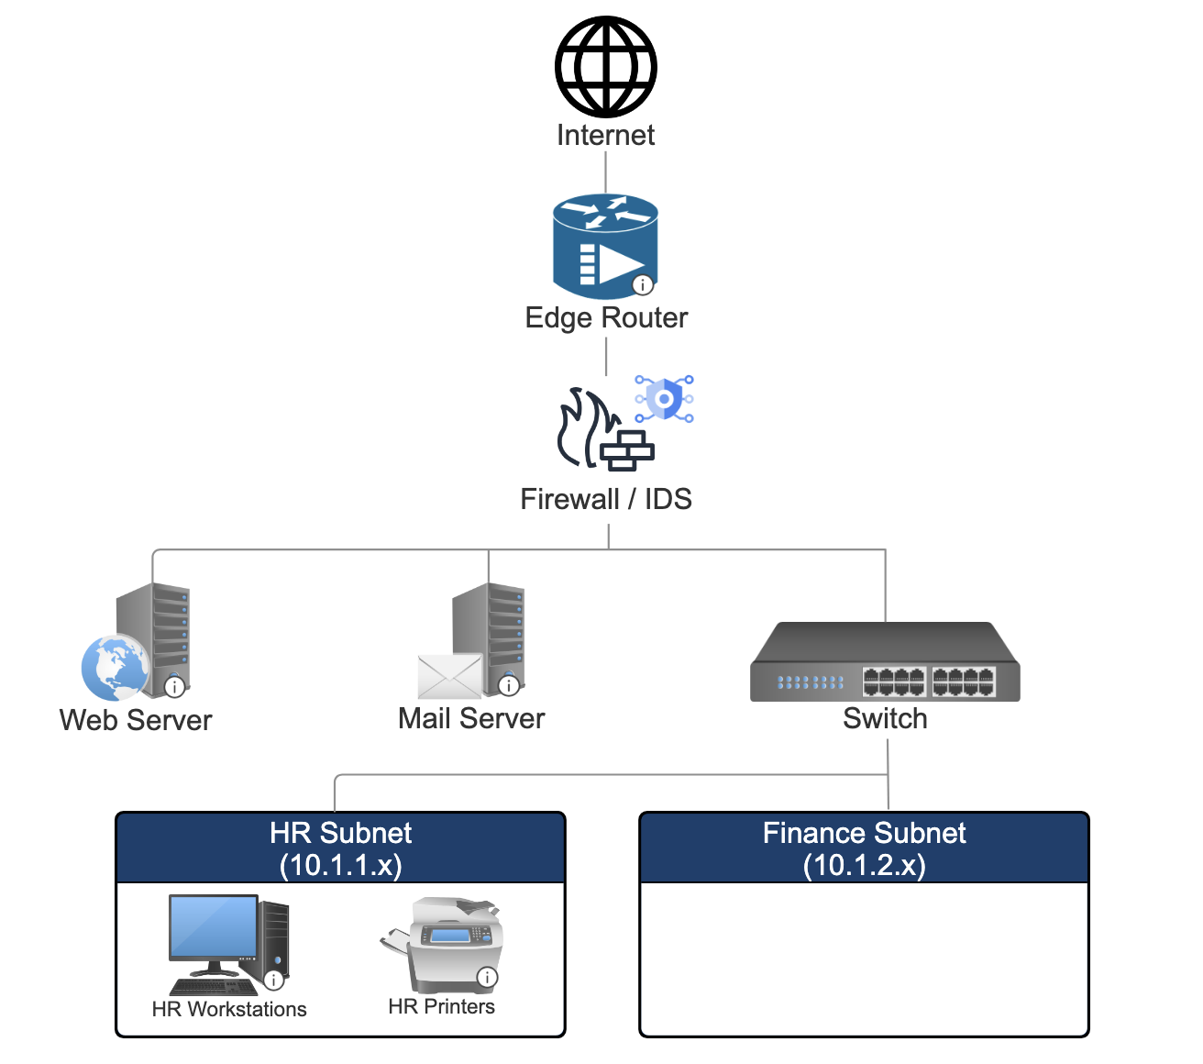

4. Firewall Rule Set (Excerpt)

Rule # | Source | Destination | Port/Service | Action
100 | Any | Web server | 443 (HTTPS) | Allow
101 | Any | Email server | 25 (SMTP) | Allow
102 | Any | Internal networks | Any | Allow
103 | Internal | External | Any | Allow
104 | Any | Firewall console | 8080 | Allow

5. IDS Alert Log (Excerpt)
Time Stamp | Alert Type | Source IP | Destination IP | Description
06/24/2025 – 09:50 | Outbound C2 Traffic | 10.1.1.45 | 45.33.122.88 | Possible GhostX RAT traffic
06/24/2025 – 10:14 | Port Scan Attempt | 162.155.10.102 | 10.1.2.4 | External host scanning internal subnet
06/24/2025 – 10:45 | Unauthorized Access | 10.1.1.45 | 10.1.2.10 | Lateral movement via SMB
06/25/2025 – 08:02 | Suspicious DNS Query | 10.1.1.45 | 8.8.8.8 | Query to known malicious domain

